**Technical Solution Approach – Azure AD Authentication with .NET**

Team Member:

A.Ahamed Shabith

Manish S N

Ramunaathan K

Ruthvik S

Rathiesh Prasad

Athish B S

Contents

1 Introduction 2

1.1 About this document 2

1.1.1 Purpose & Scope of the document 2

2 Component Design 2

2.1 Component Design Diagram 2

2.1.1 Overall Workflow 2

2.1.2 Low level Design 2

3 Technology & Frameworks to be used 3

4 Solution Approach 3

# Introduction

## About this document

### Purpose

The goal of this document is to explain how to create a Web application in.NET that uses the Azure AD authentication technique to verify user identity. The project's general procedure is described in this document. This document also contains a list of the specific requirements needed for this project.

### Scope of the project

.NET was used in the creation of this project. The main goal of this project is to create a module or component that can be used in.NET applications to enable Azure AD authentication. The authentication Module or component is a class library that enables developers to reuse the service component when using Azure Active Directory authentication. Since basic authentication functionality is frequently utilised in practically all application development, this component was created in a generic and reusable manner to allow it to be linked with any.NET application.

# Component Design

## Component Design Diagram

This section explains the details about how the component design is and why the component is designed in the specific way. This section showcases the flow chart, the sequence diagram, and the class diagram for the overall functionality.

### Overall Workflow

Workflow diagram below is for the Authentication.

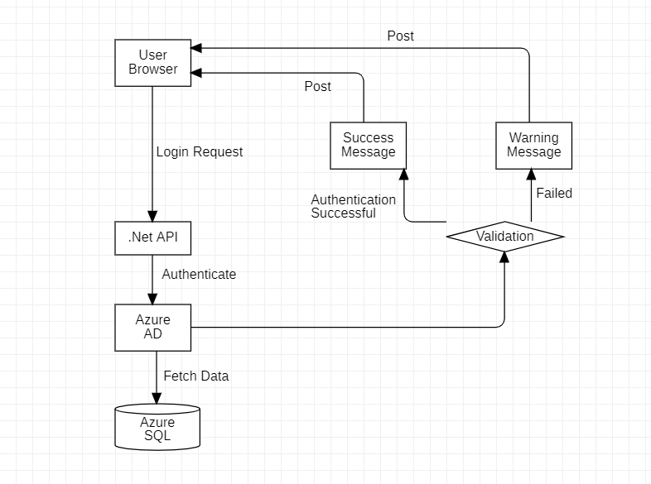

Sequence diagram for the user authentication as below:

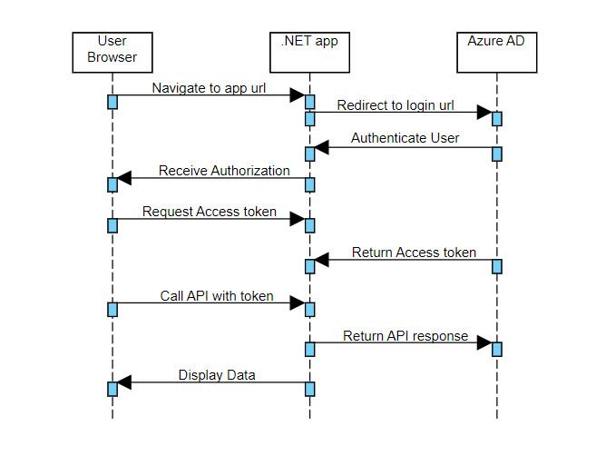

### Low level Design

This section explains the details end to end workflow with the method level details. Below is the sample diagram just for reference.

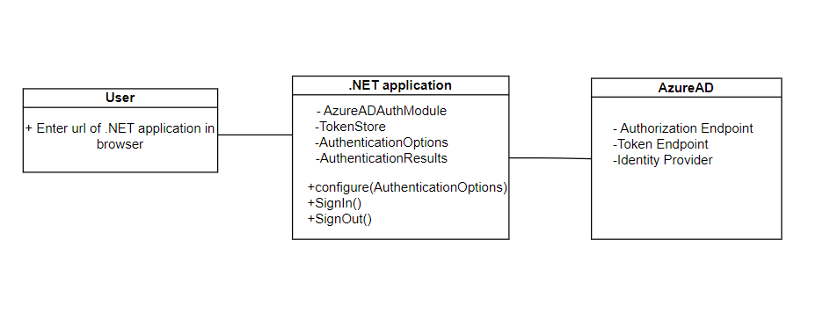

# Technology & Frameworks to be used

This section should list down the details on technology and framework used for development as well as for testing.

E.g.

1. .NET 6.0
2. Azure AD service

# Solution Approach

1. Create a reusable module or component that can authenticate .net applications using azure ad. The functions of the module would be:
2. Set up the ASP.NET Core application's authentication middleware to use Azure AD as the authentication provider.
3. Implement authentication and authorization in the application.
4. Develop methods for authenticating the user and receiving an access token from Azure AD, including managing the authentication flow and collecting the authorization code and token.
5. This component will be created as a self-dependent module.
6. We will create a sample test application and we will invoke the newly created component.
7. The page x will be imported with the component and checked to verify the compatibility.
8. The page will redirect and check the user is present in the database or not.
9. If the authentication is successful, a new page will load displaying the message “Authentication successful”.
10. If the authentication is unsuccessful, a warning message with “Authentication Unsuccessful” will be displayed in the same page.